2025 Calendar and Paydays
January 1- New Year’s Day
March 24 - Staff Development (Closed)
April 18- Good Friday
May 26⁻ Memorial Day
July 4- Independence Day
September 1- Labor Day
November 10- Staff Development (Closed)
November 27-Thanksgiving
November 28- Thanksgiving Break
December 24- Christmas Eve
December 25- Christmas Day Eve
December 26 – Christmas Break
Key
Day off/Holiday

Pay Day

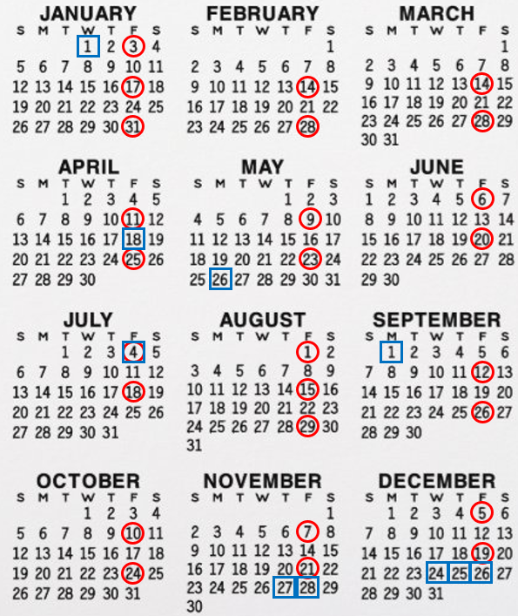
DAYS OF SERVICE SUPPORTED WORK, AND VACATIONS: Clients in supported work positions in the community, Bearly Used Thrift Store, or The Depot, may be asked by their employers to work during times when the Center is closed. If clients need support, supervision or transportation during these times, the DAC will make staff available. Clients wishing to take time off for vacations or for family reasons are encouraged to take a total of two or three weeks during the year. The Designated Coordinator should be notified when a client wishes to take time off.
SNOW DAYS: If the weather is bad, the DAC will close when the Park Rapids Schools close. Listen for announcements on the radio or check the DAC Facebook page. In the event of an E-learning day the DAC will decide based on weather conditions and the announcement will be on the radio as well as the Facebook page.

ABSENCES: If you are going to be absent, please call the DAC! Call the evening before or early in the morning so the driver does not have to make an unnecessary trip to your home.
DAC Bus Routes Call the DAC at 218-732-3358 (to leave a message on the answering machine)
Heartland Express Bus cell phone 218- 255-1199 or back up # 218- 255-5767

11/4/2024

